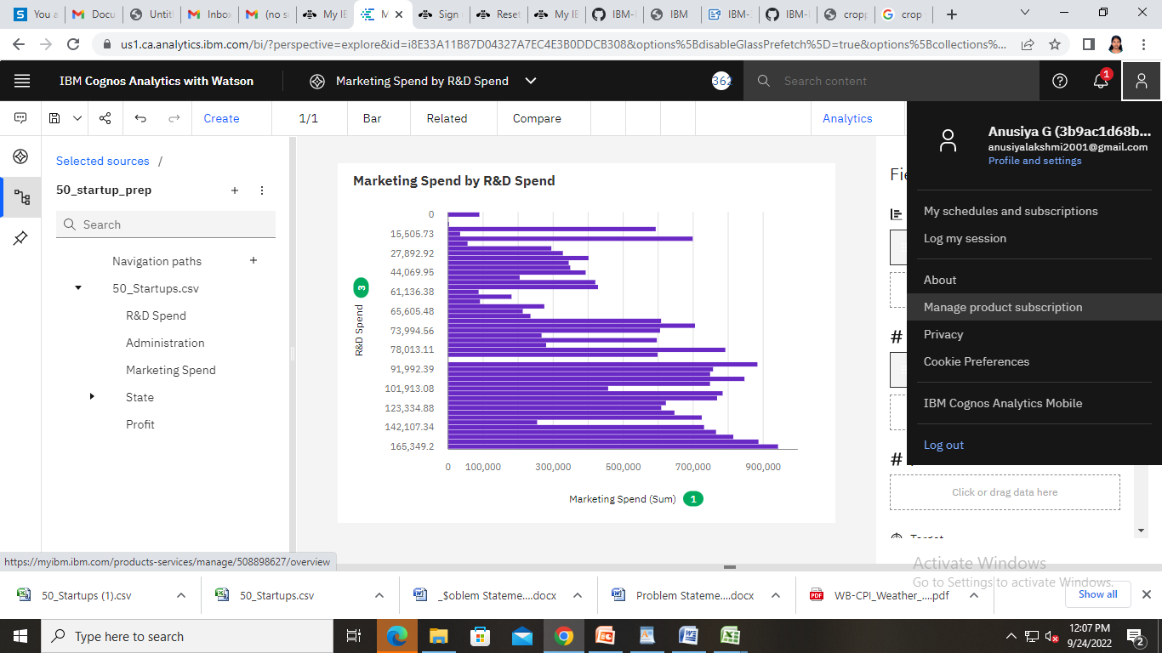<https://us1.ca.analytics.ibm.com/bi/?perspective=explore&pathRef=.my_folders%2FMarketing%2BSpend%2Bby%2BR%2526D%2BSpend&subView=model000001836e31c3c7_00000004>

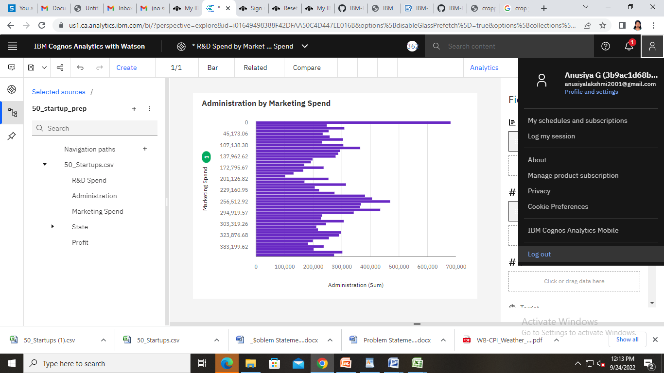

<https://us1.ca.analytics.ibm.com/bi/?perspective=explore&pathRef=.my_folders%2FR%2526D%2BSpend%2Bby%2BMarketing%2BSpend&subView=model000001836e31c3c7_00000004>

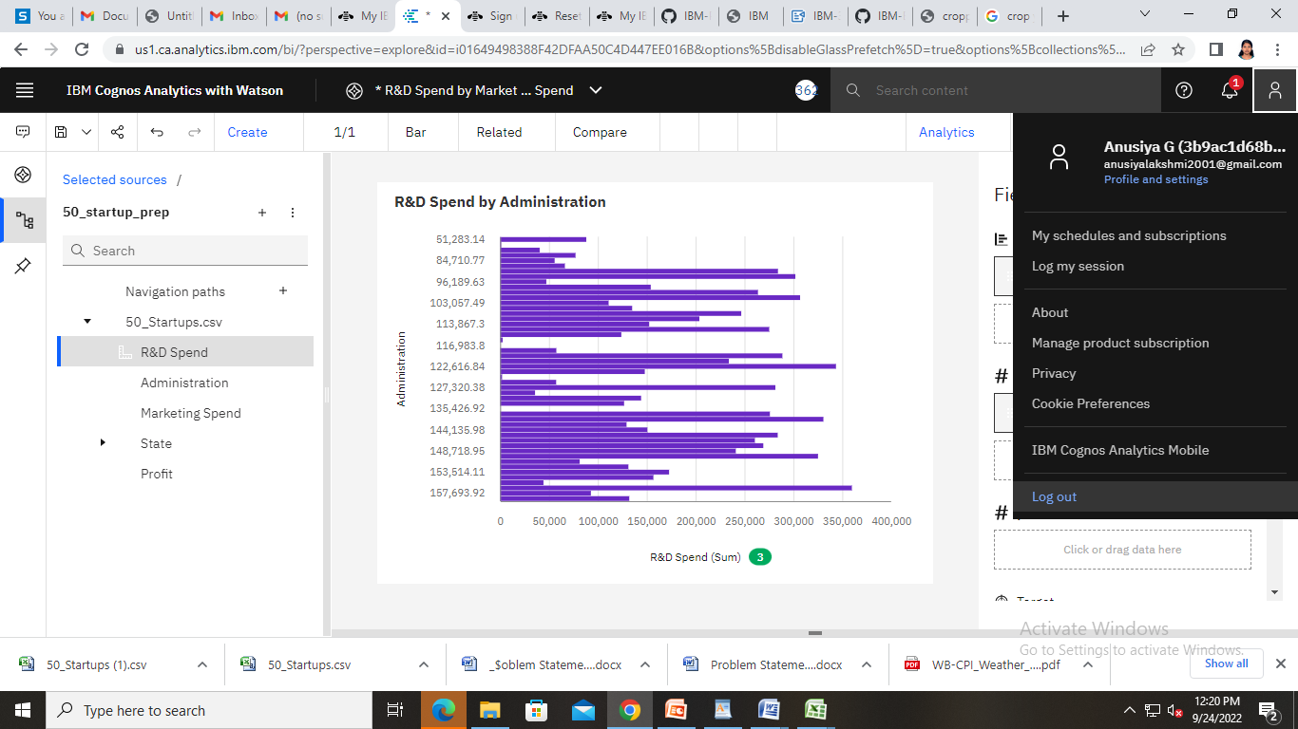

<https://us1.ca.analytics.ibm.com/bi/?perspective=explore&pathRef=.my_folders%2FR%2526D%2BSpend%2Bby%2BMarketing%2BSpend&subView=model000001836e31c3c7_00000004>

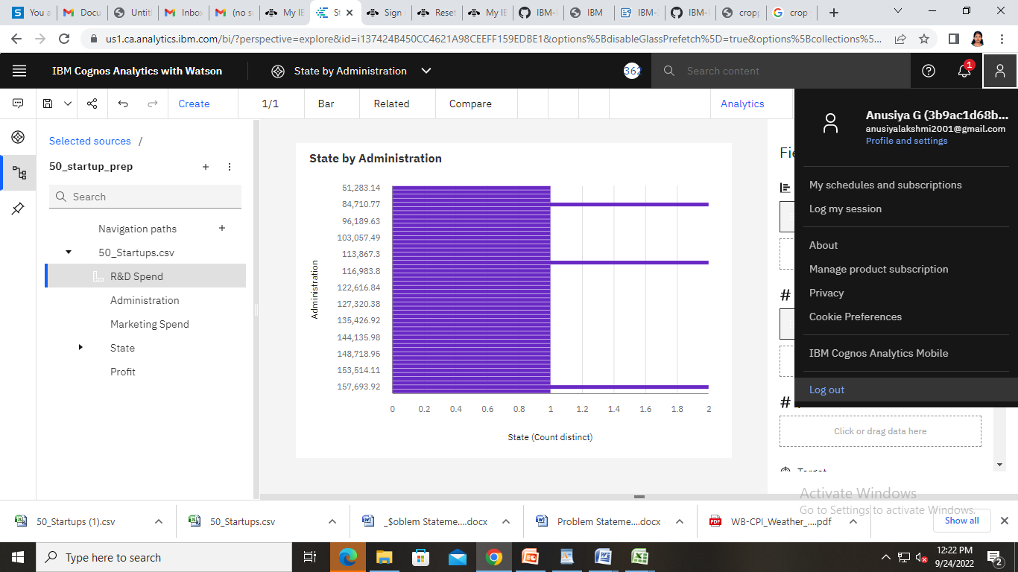

<https://us1.ca.analytics.ibm.com/bi/?perspective=explore&pathRef=.my_folders%2FState%2Bby%2BAdministration&subView=model000001836e31c3c7_00000004>

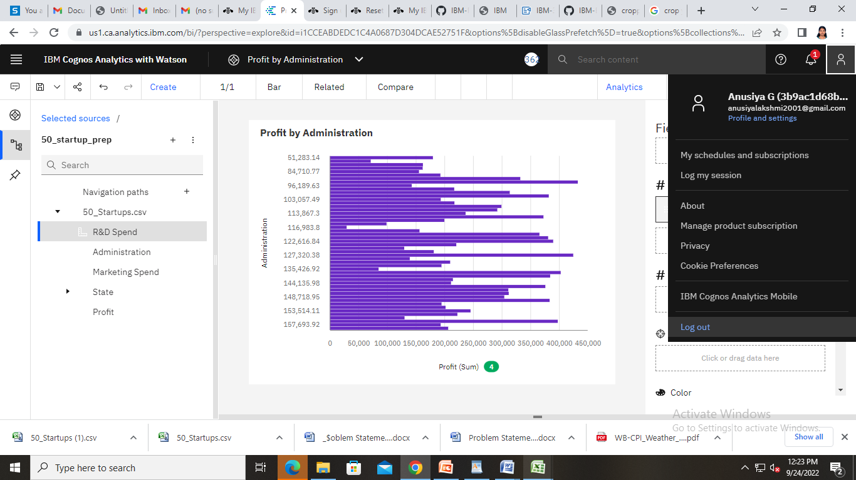

<https://us1.ca.analytics.ibm.com/bi/?perspective=explore&pathRef=.my_folders%2FProfit%2Bby%2BAdministration&subView=model000001836e31c3c7_00000004>

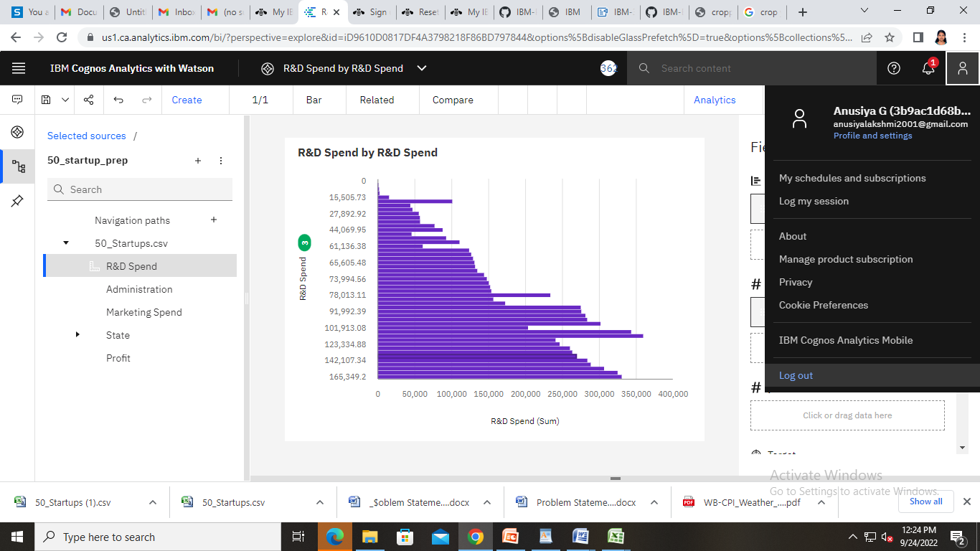

<https://us1.ca.analytics.ibm.com/bi/?perspective=explore&pathRef=.my_folders%2FR%2526D%2BSpend%2Bby%2BR%2526D%2BSpend&subView=model000001836e31c3c7_00000004>

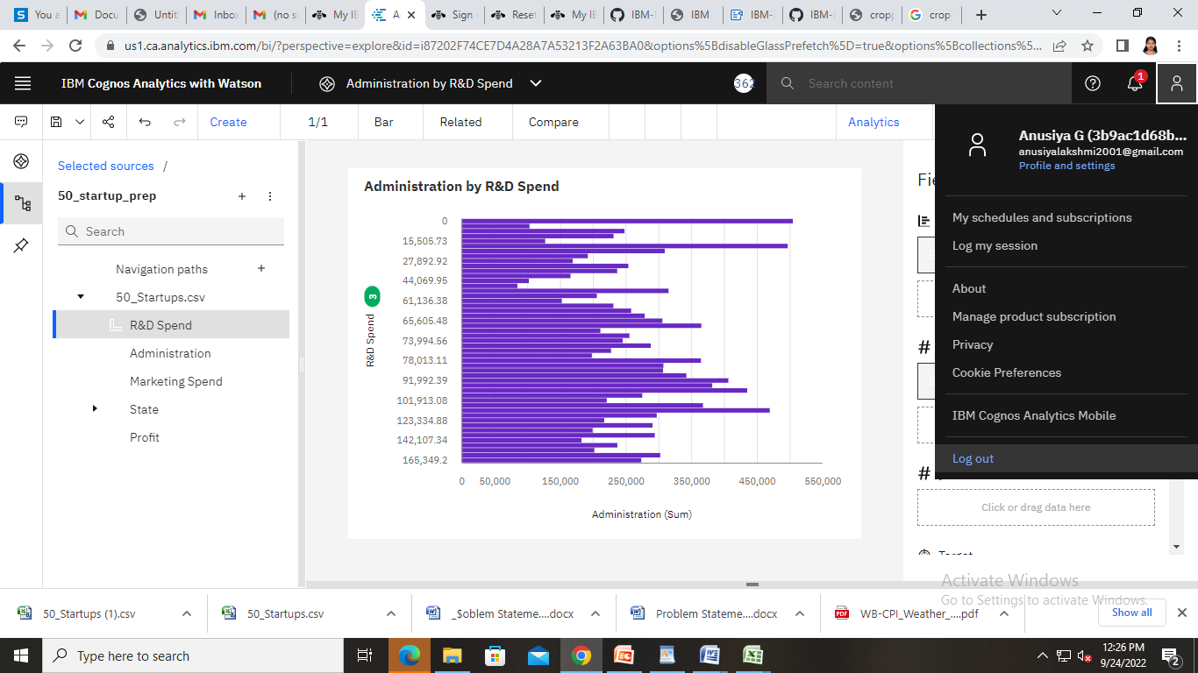

<https://us1.ca.analytics.ibm.com/bi/?perspective=explore&pathRef=.my_folders%2FAdministration%2Bby%2BR%2526D%2BSpend&subView=model000001836e31c3c7_00000004>

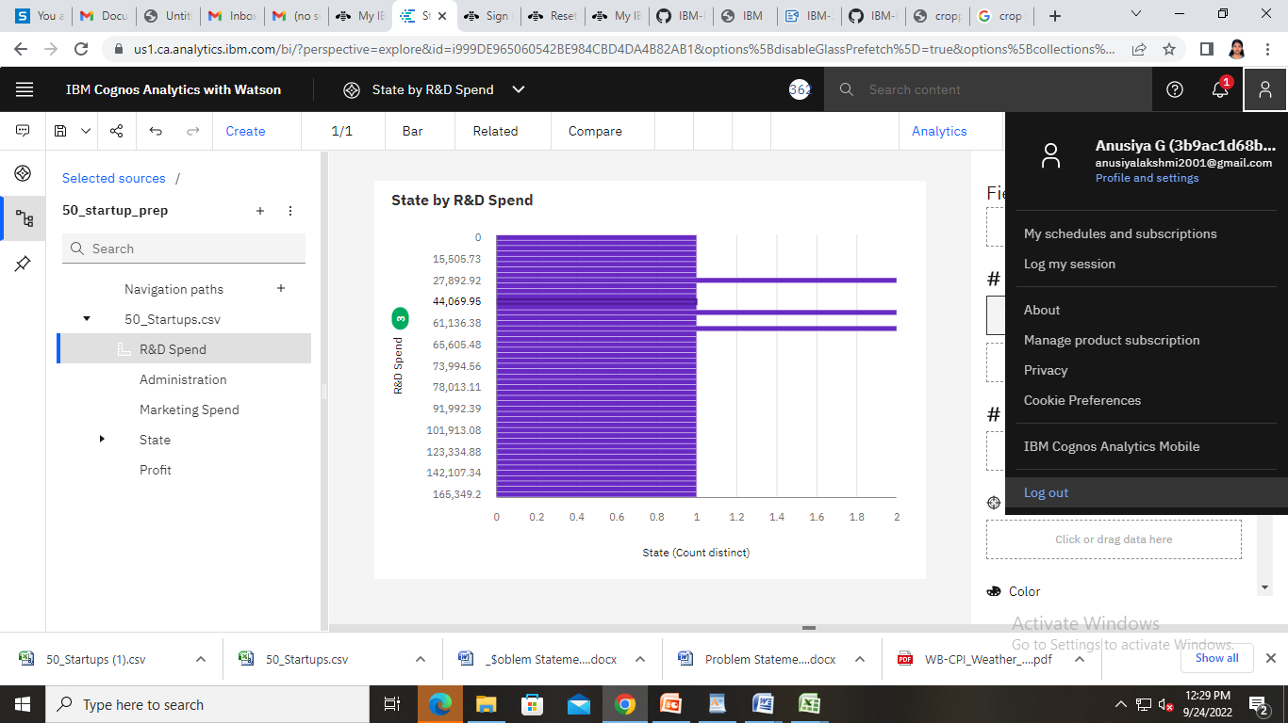

<https://us1.ca.analytics.ibm.com/bi/?perspective=explore&pathRef=.my_folders%2FState%2Bby%2BR%2526D%2BSpend&subView=model000001836e31c3c7_00000004>

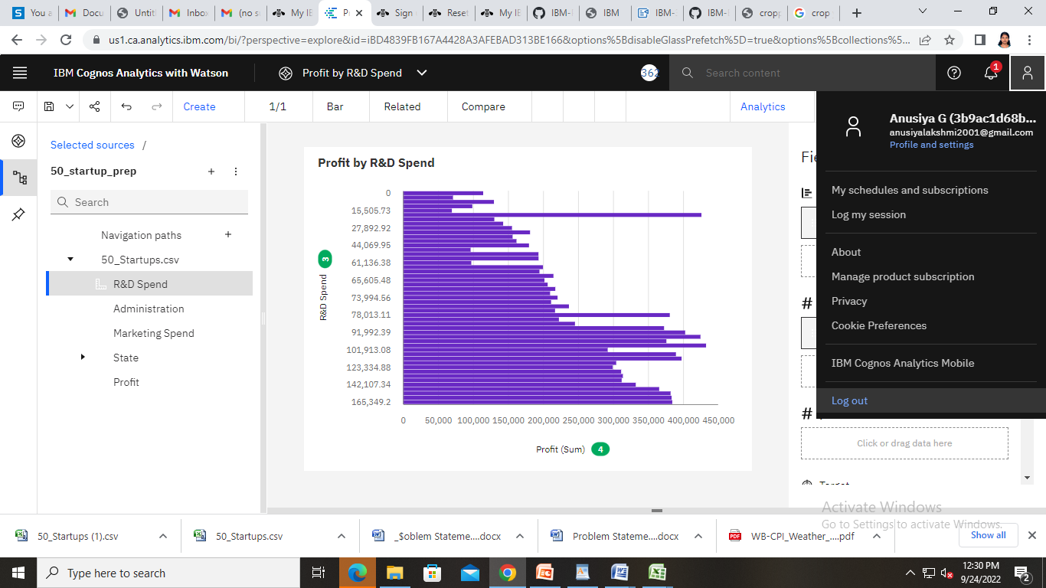

<https://us1.ca.analytics.ibm.com/bi/?perspective=explore&pathRef=.my_folders%2FProfit%2Bby%2BR%2526D%2BSpend&subView=model000001836e31c3c7_00000004>

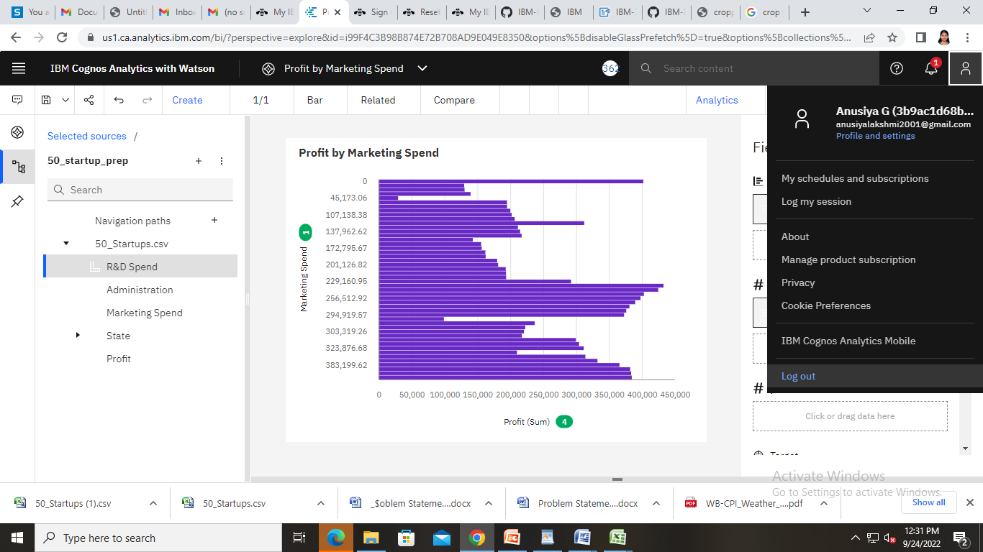

<https://us1.ca.analytics.ibm.com/bi/?perspective=explore&pathRef=.my_folders%2FProfit%2Bby%2BMarketing%2BSpend&subView=model000001836e31c3c7_00000004>

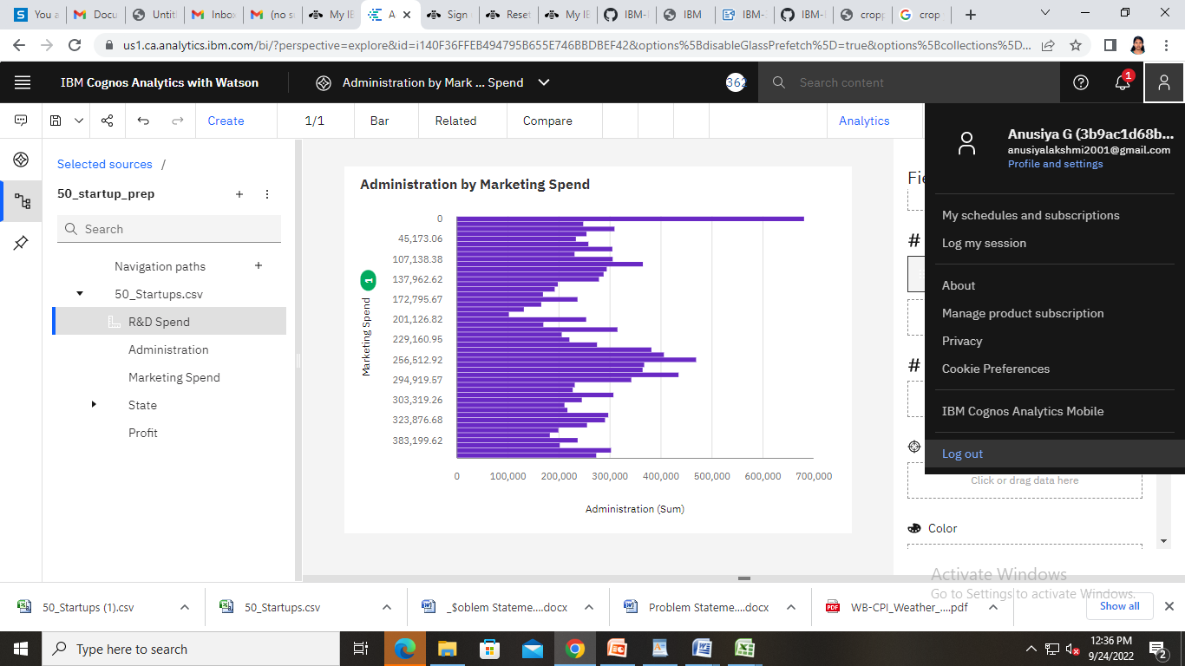

<https://us1.ca.analytics.ibm.com/bi/?perspective=explore&pathRef=.my_folders%2FAdministration%2Bby%2BMarketing%2BSpend&subView=model000001836e31c3c7_00000004>

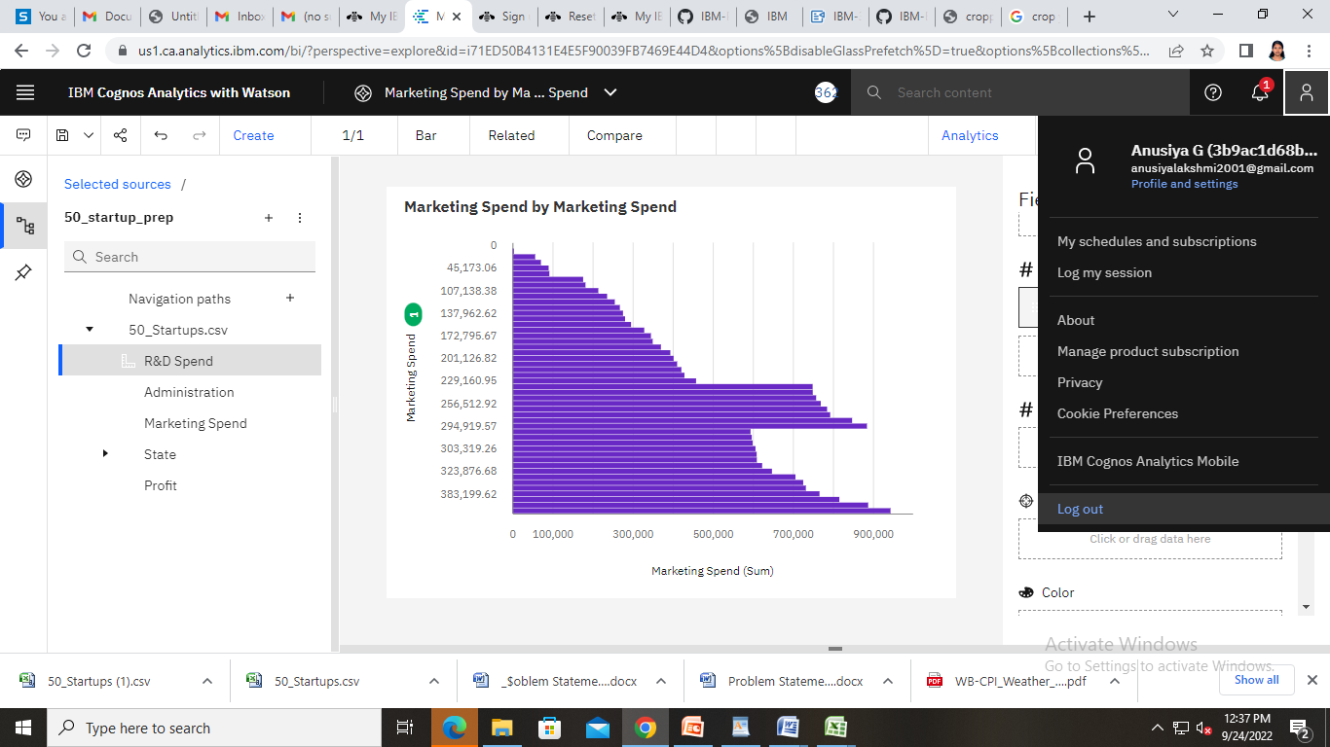

<https://us1.ca.analytics.ibm.com/bi/?perspective=explore&pathRef=.my_folders%2FMarketing%2BSpend%2Bby%2BMarketing%2BSpend&subView=model000001836e31c3c7_00000004>

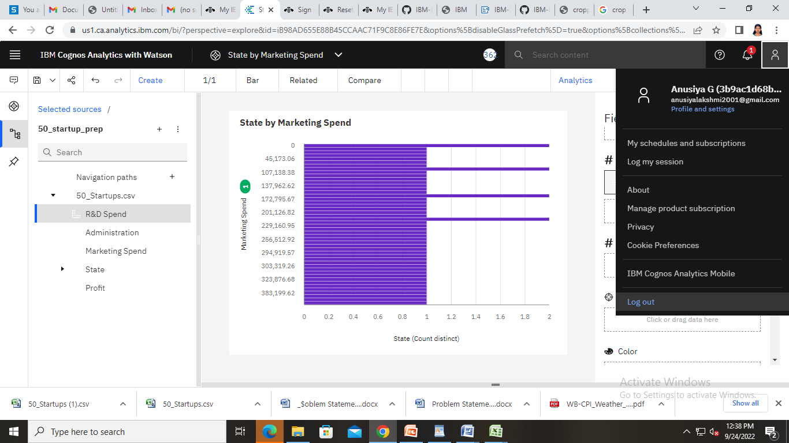

<https://us1.ca.analytics.ibm.com/bi/?perspective=explore&pathRef=.my_folders%2FState%2Bby%2BMarketing%2BSpend&subView=model000001836e31c3c7_00000004>

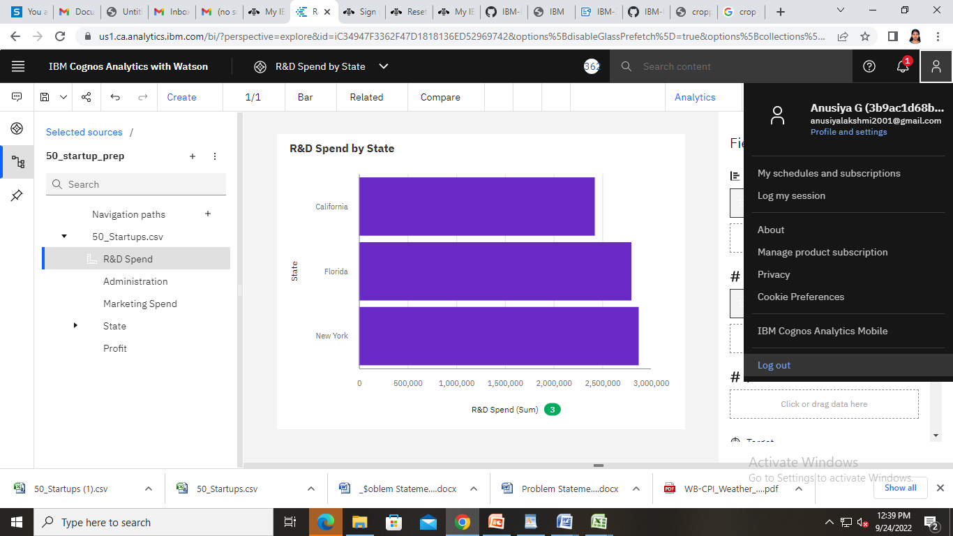

<https://us1.ca.analytics.ibm.com/bi/?perspective=explore&pathRef=.my_folders%2FR%2526D%2BSpend%2Bby%2BState&subView=model000001836e31c3c7_00000004>

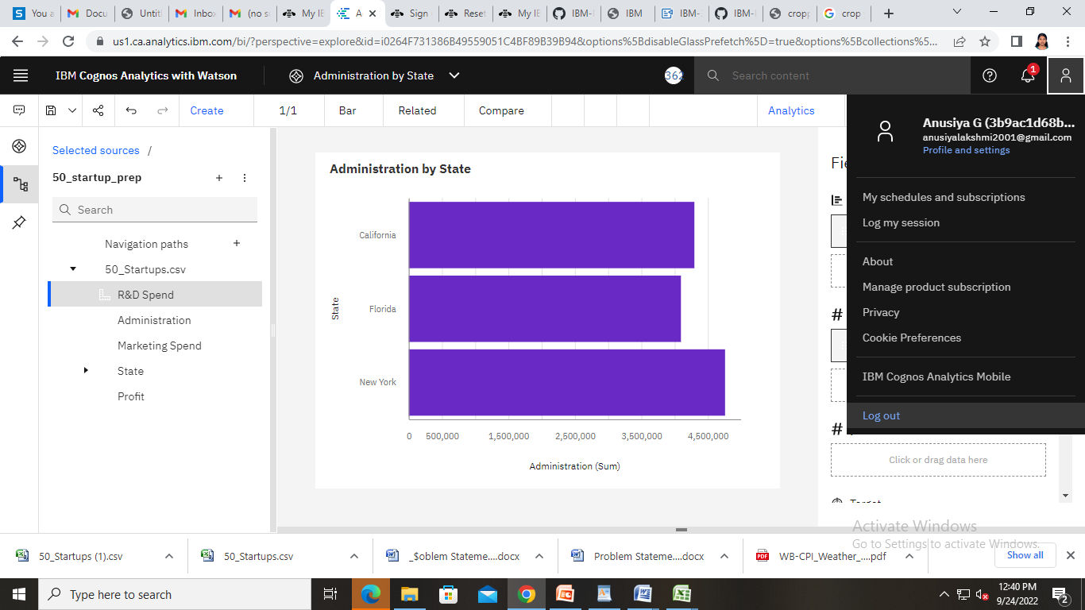

<https://us1.ca.analytics.ibm.com/bi/?perspective=explore&pathRef=.my_folders%2FAdministration%2Bby%2BState&subView=model000001836e31c3c7_00000004>

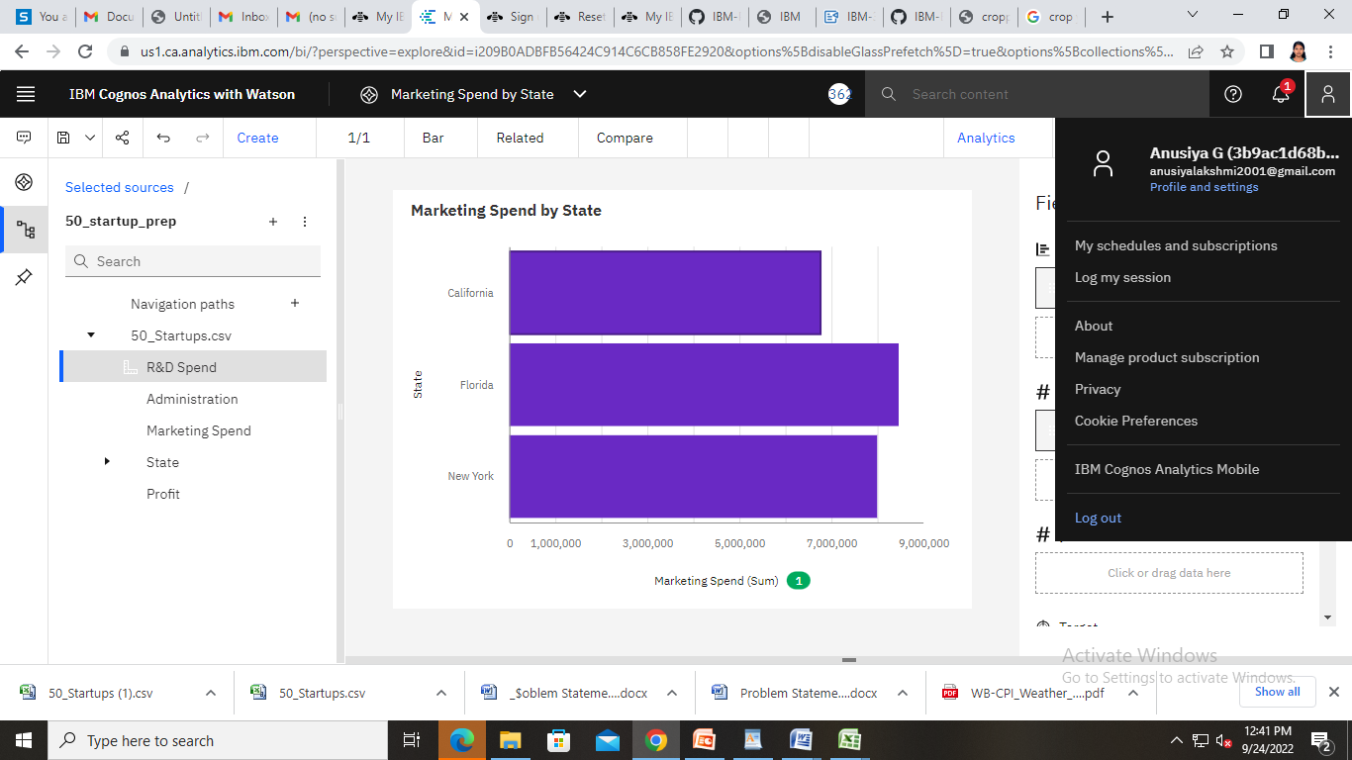

<https://us1.ca.analytics.ibm.com/bi/?perspective=explore&pathRef=.my_folders%2FMarketing%2BSpend%2Bby%2BState&subView=model000001836e31c3c7_00000004>